|  |  |  |  |
| --- | --- | --- | --- |
| Club/Group Name |  | | |
| Name of Event |  | | |
| Date of Event |  | | |
| Coordinator Name: |  | Contact Number: |  |
| Email |  | | |

**ARRIVAL DETAILS:**

All vehicles/caterers/coordinators are to enter the museum grounds via CHURCH STREET gate unless arranged otherwise with museum staff in advance. A map will be supplied once booking is confirmed.

Museum opening hours of 10:00 am to 5:00 pm for events outside of these hours additional charges may apply.

|  |  |  |  |
| --- | --- | --- | --- |
| Bump In: |  | Event Start Time: |  |
| Bump Out: |  | Event Finish Time: |  |
| Number of vehicles:* |  | Number of people attending |  |

**ONSITE CATERING/VENDORS**

|  |  |
| --- | --- |
| Do you plan to book caterers  or vendors for the event? Yes, no, or TBC |  |

If yes, the Visitor Engagement Coordinator will be in touch.

The following fees are applicable to onsite caterers and vendors - please check which one is applicable to your event:

Site fee - Commercial Event stalls/caterers $ 320

Site fee - Community Event stalls/caterers $ 70

**PARKING**

\***Only vehicles registered with the attending club are permitted on museum grounds.** Daily drives or vehicles that are not within the ‘theme’ of the group are required to park in the main museum carpark and pay admission to gain access. Vehicle clubs enjoy the manicured grounds free of charge thanks to the support of the Bay to Birdwood and Shannons and add to our visitors’ experience.

Vehicles parking on museum grounds will be parked by museum staff that have been trained to do so. The museum will provide this free of charge for groups under 50 vehicles.

*0 to 49 vehicles, free of charge*

For gatherings of 50 or more vehicles marshal fees as follows:

*50 to 99 vehicles, $180*

*100 to 200 vehicles, $240*

*200 to 300 vehicles, $300*

**OTHER INFORMATION**

Is there any other information relating to your event?

|  |
| --- |
|  |

**Use of the National Motor Museum Grounds is free of charge thanks to the generous support of the RAA Bay to Birdwood**. If your club wishes to hire additional infrastructure or venue rooms, please indicate below:

Indicate which area you wish to hire:

## Venue Area

Indoor Function Room $315

Outdoor Vergola area FOC

#### Includes exclusive use of area, urn, fridge, BBQ, table and chairs.

Maximum of 50 seated or 80 standing

### Indoor BBQ & Pergola maximum 120 seating

Main Grounds - BBQ area FOC

Hut Across the river FOC

## Grounds

Museum Grounds for club parking FOC

Hire of Grounds - external marquee/s to be installed $2500

Prices include the provision of power to sites, bins, co-ordination

Alternatively, we can provide a complete event management service for your event at a

fee plus costs for the hire of equipment. Please discuss this with our Event Coordinator.

**Hire of equipment in addition**

Data Projector $50

PA System $50

Plastic tubs for drinks $5 each

Trestle Tables – 6’ (8 available) $10 each

Chairs (white no arms, 100 available) $2.50 per chair

Chairs (white with arms – 35 available) $2.50 per chair

1 x 6x3 marquee with 3 sides $50

2 x 3x3 marquee with 3 sides $35 each

3 x 3x3 canopies with roof only $20 each

Portable picket fencing 2.4m lengths $30 per length

All prices quoted are GST inclusive.

**PRICING DETAILS**

|  |
| --- |
| Donations made to the Museum’s current restoration project are greatly appreciated. Please speak to Museum staff while you are at the museum for more information. |

**Conditions of Hire:**

All prices are for hire within standard operating hours of 10:00 am to 5:00 pm. Events outside of standard operating hours require a minimum of two staff at a rate of $60 per hour per person.

If National Motor Museum staff are required to assist in the set-up of the function or event, a rate of $40 per hour per person applies.

Please tick the following boxes to acknowledge that your event will adhere to these conditions:

**NO PEGS** are to be used on the museum grounds. All marquees and shelters are to use adequate weights.

Any electrical item brought on-site by the hirer or caterer must be tested and tagged.

Dogs are not permitted on museum grounds. Accredited assistance animals with appropriate credentials are permitted. Dog owners are required to always keep animals on a lead no longer than 2m and to clean up after them.

We are committed to ensuring the safety of employees, volunteers, contractors, and visitors to the National Motor Museum. If a Fire Danger Rating CATASTROPHIC (Code Red) Level is declared by the CFS for the Mount Lofty District, the Museum will be closed. Should this occur, we will endeavour to contact you as soon as possible to advise you of the closure, however, it is your responsibility to arrange an alternative venue.

By holding an event at the National Museum your email address will be added to our Vehicle Club Database. You can unsubscribe from this at any time.

Name of person filling in the form

|  |
| --- |
|  |

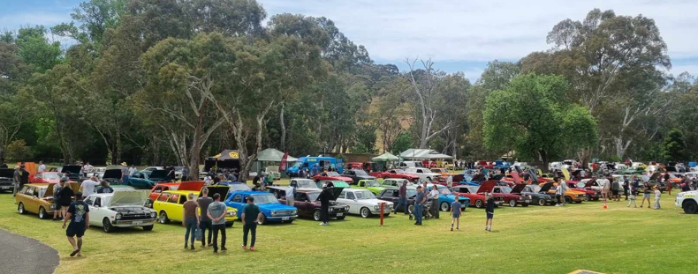

All Datsun Day October 2023, 134 vehicles parked on main museum grounds

