Club/Group Name
Name of Event
Date of Event
Coordinator Name: |  | Contact Number:
Email

ARRIVAL DETAILS:
All vehicles/caterers/coordinators are to enter the museum grounds via CHURCH STREET gate unless arranged otherwise with the museum event coordinator. A map will be supplied once bookings are confirmed.
Museum opening hours of 10:00 am to 5:00 pm for events outside of these hours additional charges may apply.
Bump In: |  | Event Start Time:
Bump Out: |  | Event Finish Time:
Number of vehicles: |  | Number of people attending

ONSITE CATERING/VENDORS
Do you plan to book caterers or vendors for the event? Yes, no, or TBC
If yes, the museum Event Coordinator will be in touch.
The following fees are applicable to onsite caterers and vendors - please check which one is applicable to your event:
Site fee - Commercial stalls/caterers $ 100
Site fee - Community stalls/caterers $ 50

PARKING
Vehicles parking on museum grounds need to be marshaled by SAPOL trained marshals. The museum will provide this free of charge for groups under 50 vehicles. For gatherings of 50 or more vehicles additional marshals will be required.
Museum marshals are charged at $60 per hour per staff member for at least three hours. If your club already has SAPOL trained parking marshals, please indicate below.

Yes, please supply the required marshals.
No, the club will supply their own or they are not required.

OTHER INFORMATION
Is there any other information relating to your event?

Use of the National Motor Museum Grounds is free of charge thanks to the generous support of Shannons and the Bay to Birdwood. If your club wishes to hire additional infrastructure or venue rooms, please indicate below:

Indicate which area you wish to hire:

Venue Area
Indoor Function Room $150
Outdoor Vergola area FOC

Includes exclusive use of area, urn, fridge, BBQ, table and chairs.
Maximum of 50 seated or 80 standing

Indoor BBQ & Pergola maximum 120 seating

Main Grounds - BBQ area FOC
Hut Across the river $100

Grounds
Museum Grounds for club parking FOC
Hire of Grounds - external marquee/s to be installed $1,100
Prices include the provision of power to sites, bins, co-ordination
Alternatively, we can provide a complete event management service for your event at a
fee plus costs for the hire of equipment. Please discuss this with our Event Coordinator.

Hire of equipment in addition
Data Projector $50
PA System $50
Trestle Tables – 6’ (8 available) $10 each
Chairs (white no arms, 100 available) $2 per chair
Chairs (white with arms – 35 available) $2 per chair
1 x 6x3 marquee with 3 sides $50
2 x 3x3 marquee with 3 sides $35 each
3 x 3x3 canopies with roof only $20 each
Portable picket fencing 2.4m lengths $30 per length

All prices quoted are GST inclusive.

PRICING DETAILS

Conditions of Hire:

All prices are for hire within standard operating hours of 10:00 am to 5:00 pm. Events outside of standard operating hours require a minimum of two staff at a rate of $60 per hour per person.

If National Motor Museum staff are required to assist in the set-up of the function or event, a rate of $40 per hour per person applies.

Please tick the following boxes to acknowledge that your event will adhere to these conditions:

NO PEGS are to be used on the museum grounds. All marquees and shelters are to use adequate weights.

Any electrical item brought on-site by the hirer or caterer must be tested and tagged.

Dogs are NOT permitted on museum grounds or museum pavilions with the exception to accredited assistance animals with appropriate credentials.

We are committed to ensuring the safety of employees, volunteers, contractors, and visitors to the National Motor Museum. If a Fire Danger Rating CATASTROPHIC (Code Red) Level is declared by the CFS for the Mount Lofty District, the Museum will be closed. Should this occur, we will endeavour to contact you as soon as possible to advise you of the closure, however, it is your responsibility to arrange an alternative venue.

Name of person filling in the form

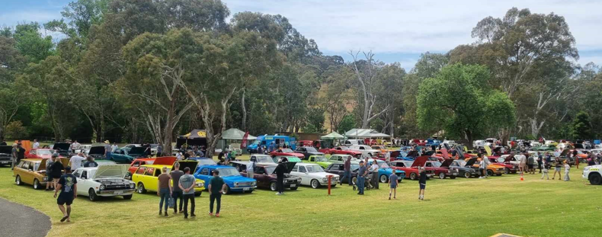
All Datsun Day October 2023, 134 vehicles parked on main museum grounds

